Beginner Linux Challenges

Task 3
- Command to create 3 files named umuzi.md, recruits.md and cohort.md below
touch umuzi.md recruits.md cohort.md
- Command to edit the document to add text within
vim cohort.md
vim recruits.md
vim umuzi.md
- Please see figure 1
figure 1
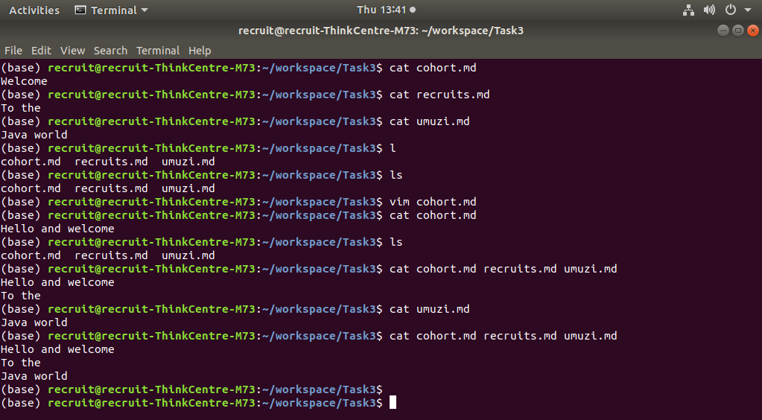
- Please see figure 2
figure 2
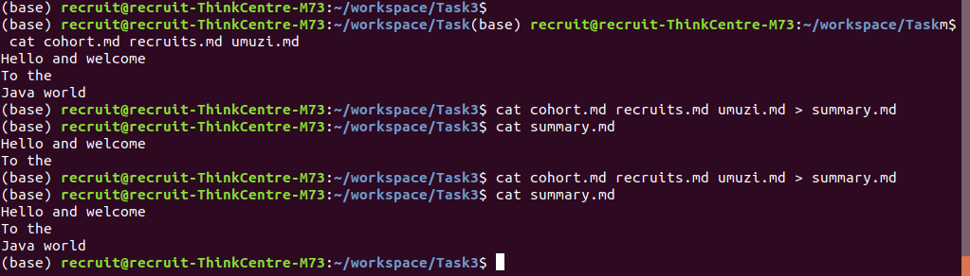
- Please see figure 3
figure 3
